3- TestRail

TestRail Administration:

By default, when an account is created, we are given admin role.

- I explored the TestRail Administration section to understand how system-level settings and configurations are managed. From the admin dashboard, I reviewed the overall environment details, including the TestRail version, build information, database version, and background task status, which helped me understand the system health and deployment setup.
- I reviewed the subscription and trial information to understand how TestRail licensing works, including trial duration, subscription status, and available options for upgrading, ordering licenses, or requesting trial extensions.
- I navigated through the Projects administration area to understand how projects are created, managed, and how access permissions are controlled at a project level for different users and roles.
- I explored the Users & Roles section to understand how users are added, deactivated, and assigned roles. This helped me learn how role-based access control is implemented in TestRail to manage permissions and responsibilities across the QA team.
- I reviewed the Customizations section to understand how standard and custom fields can be configured to tailor TestRail according to project and organizational requirements, including customization of test cases, test runs, and result fields.
- I explored the Integration settings to understand how TestRail can be connected with external tools such as defect tracking systems and requirement management tools, enabling better traceability and streamlined workflows.
- I reviewed the Site Settings and Subscription sections to understand how global configuration, email settings, backups, and subscription management are handled at the administrative level.
- This practical exercise helped me gain a clear understanding of TestRail’s administrative capabilities, system configuration options, and how centralized control is maintained for users, projects, integrations, and overall platform management.

Admin board:
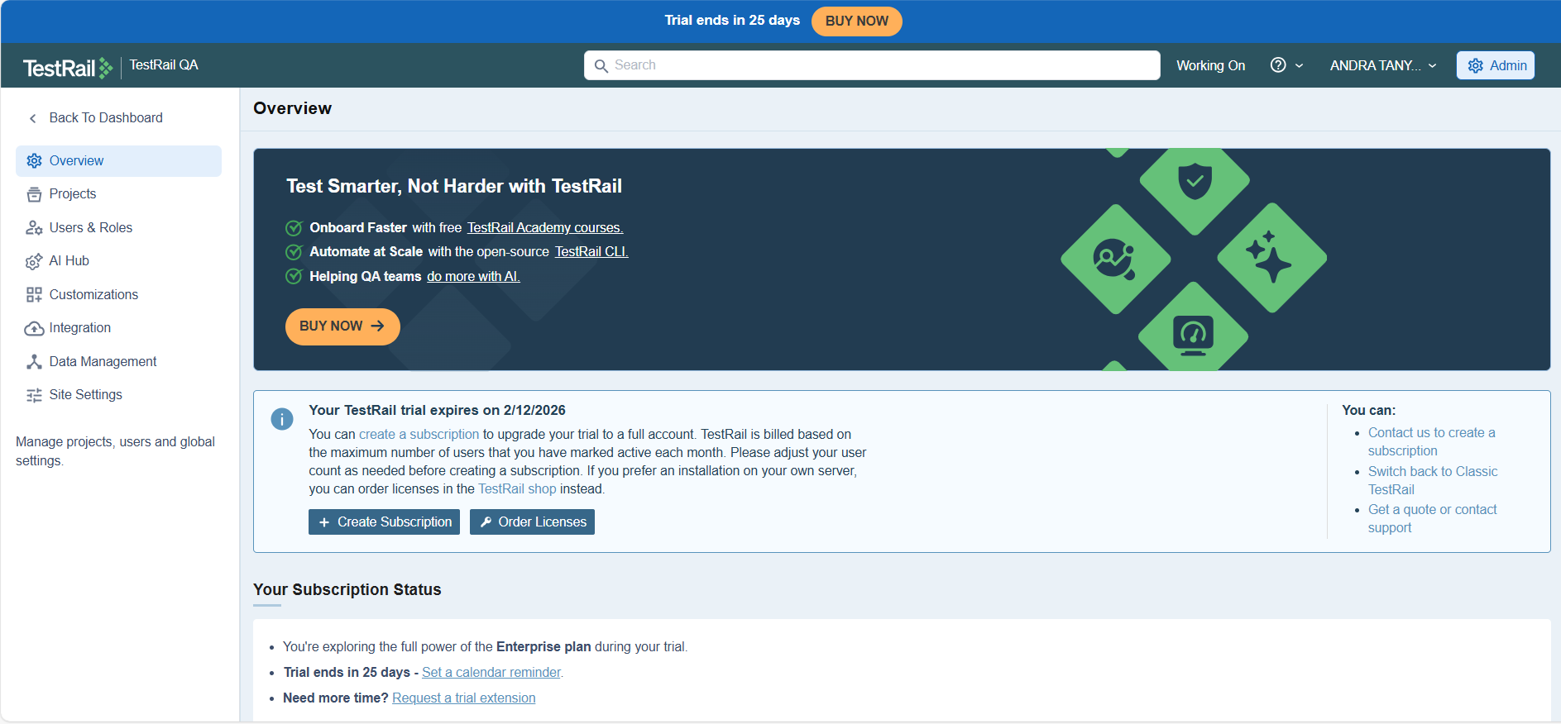

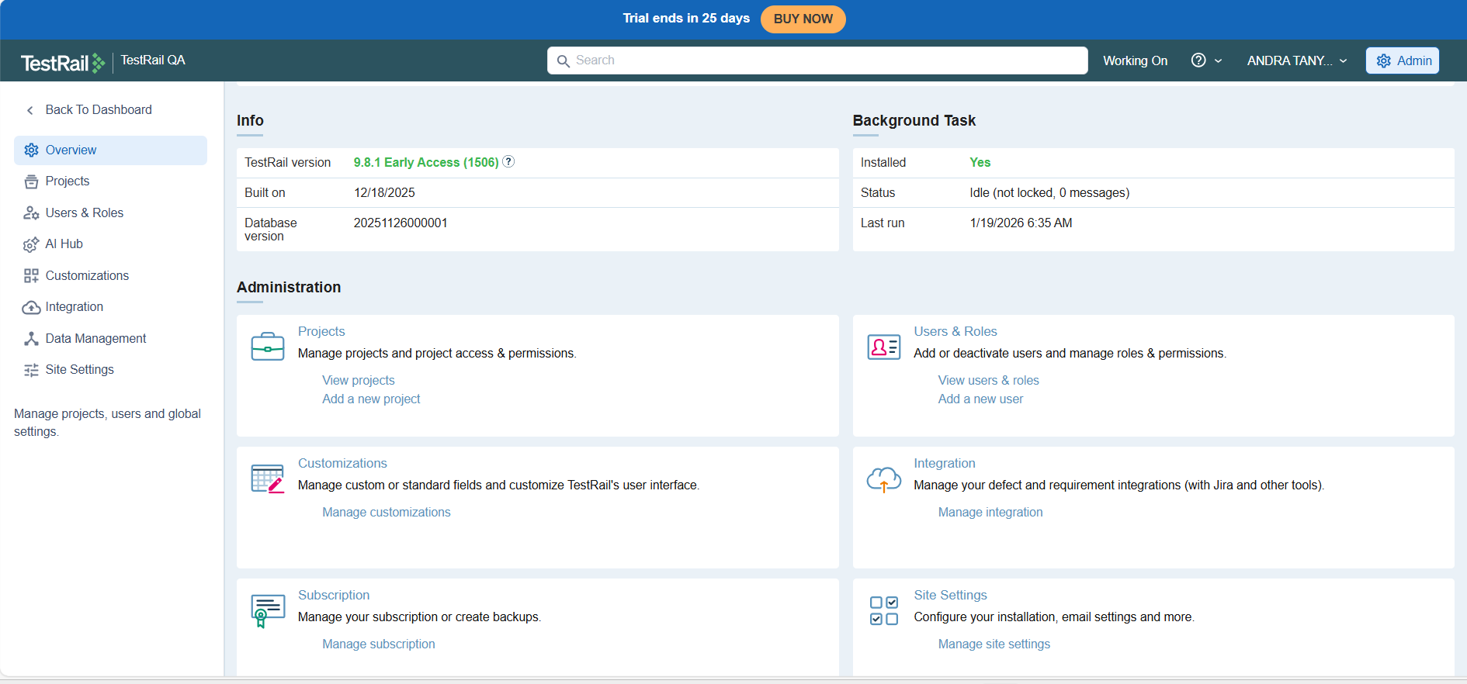

Users and Roles in TestRail: (available in admin board)

- The Users & Roles section in the Admin board allows administrators to manage user access, permissions, and responsibilities within TestRail. This section is divided into three main areas: Users, Groups, and Roles, each serving a distinct purpose in access control.
- User management was performed by adding a new user through the Users tab. While creating the user, details such as full name, email address, language, locale, and time zone were configured to ensure correct personalization and localization.
- Email notifications were enabled for the new user, allowing them to receive updates related to test changes and test results. This helps keep team members informed about testing activities.
- Authentication options were reviewed during user creation, including Single Sign-On (SSO) and multi-factor authentication. The option to invite the user via email was selected, which sends an automated invitation link for secure password setup.
- An invitation email was successfully generated and sent by TestRail, allowing the newly added user to set their password and activate their account. This confirms proper onboarding and secure access provisioning.
- After account creation, the new user appeared in the Users list with an active status, showing login type, role assignment, and activity state. Roles such as Lead and Site Admin were visible and selectable from the role dropdown.
- The Groups tab was used to organize users into logical groups. A new group named “Testers” was created, and multiple users were assigned to it. Groups help simplify project-level access management by assigning permissions collectively instead of individually.
- Group creation confirmed successful user grouping, which can later be mapped to specific projects for controlled access and collaboration.
- The Roles tab was reviewed to understand role-based permission management. Default roles such as No Access, Read-only, Tester, Designer, Lead (Default), and Site Admin were available.
- A role configuration screen was accessed to view and manage detailed permissions, including rights to add, edit, delete, and permanently delete entities like test cases, runs, plans, reports, and attachments.
- Permissions were granular and configurable, allowing administrators to control exactly what actions a role can perform. This ensures strong governance and prevents unauthorized changes within TestRail.
- The default role option was highlighted, which automatically applies to newly created users unless explicitly changed. This helps maintain consistency in access levels for new team members.
- The newly added user successfully logged into TestRail after setting the password, confirming end-to-end user onboarding from creation to first login.
- Overall, the Users and Roles functionality in TestRail enables administrators to securely manage team access, structure users through groups, and enforce role-based permissions, ensuring controlled collaboration, accountability, and scalable test management across projects.

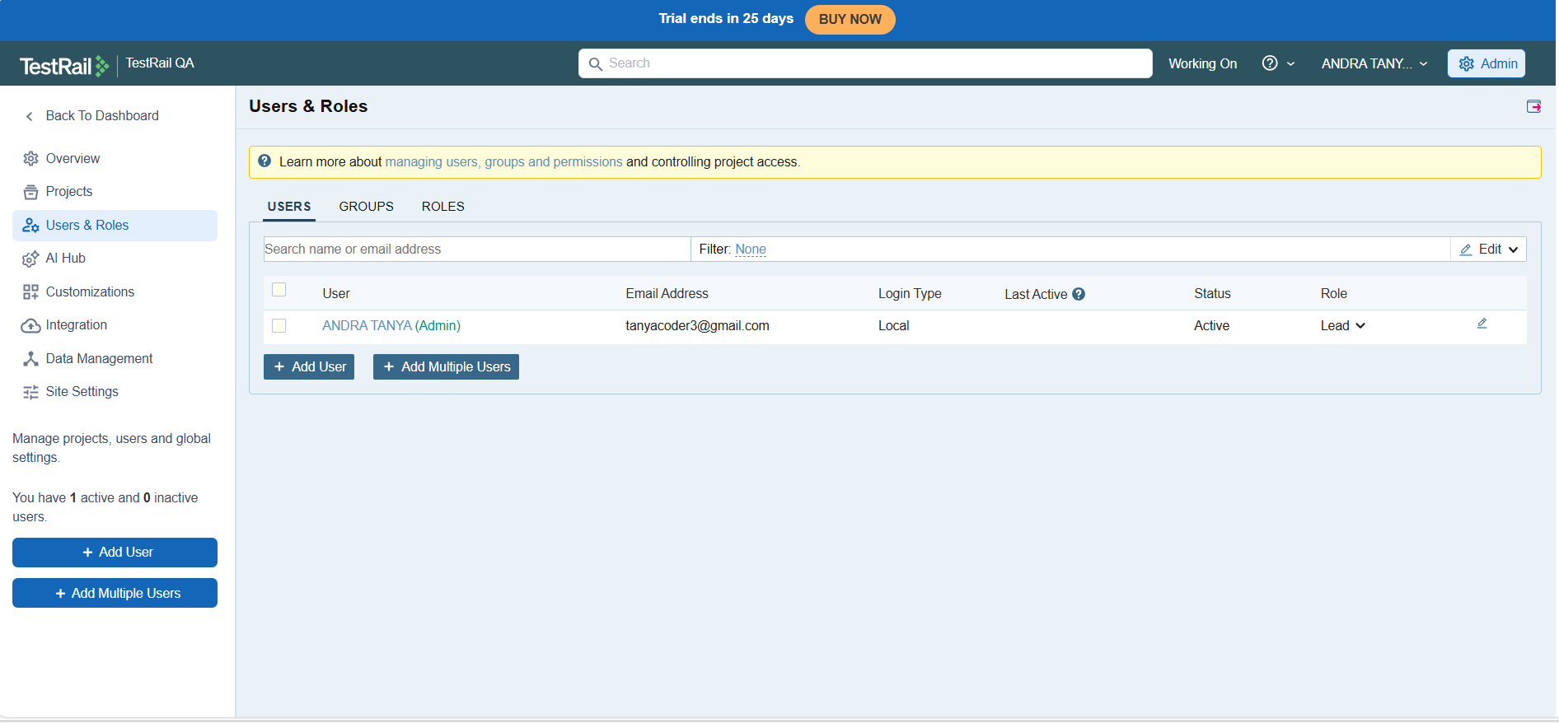

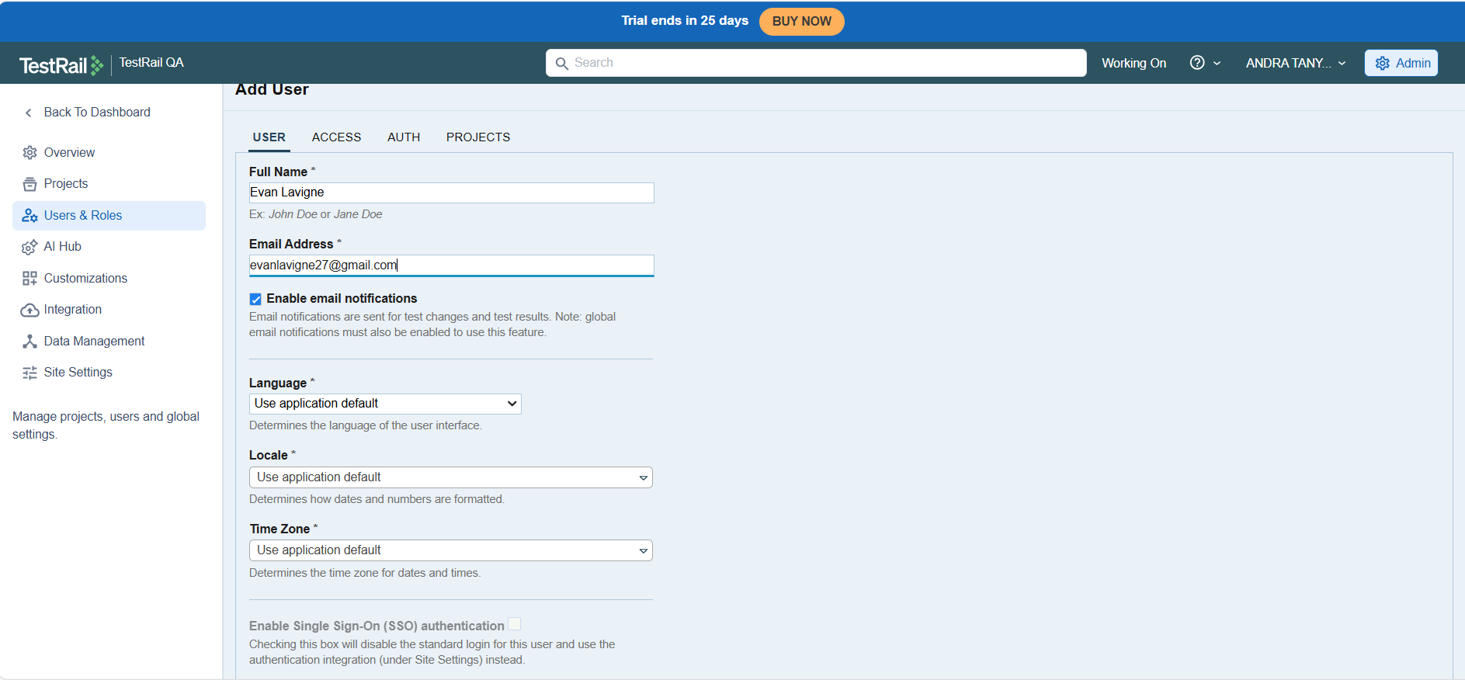

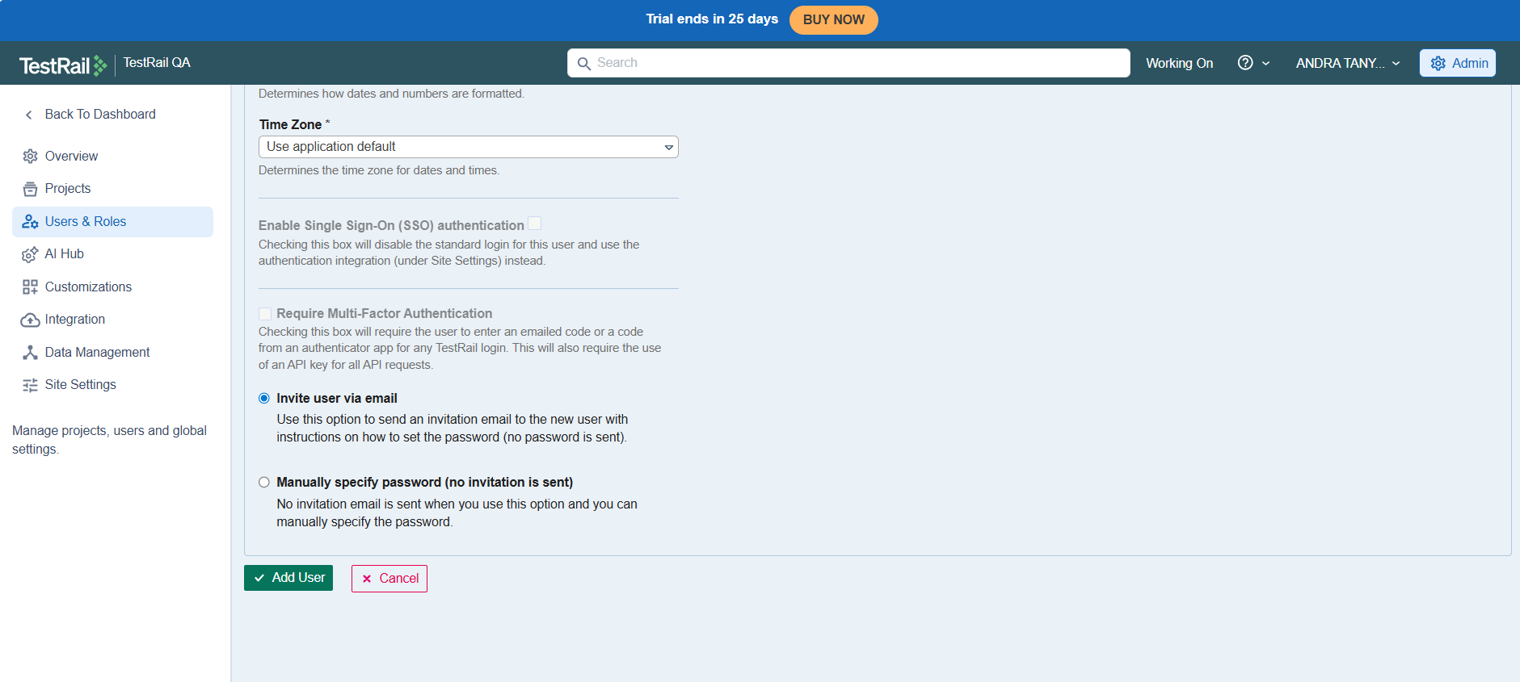

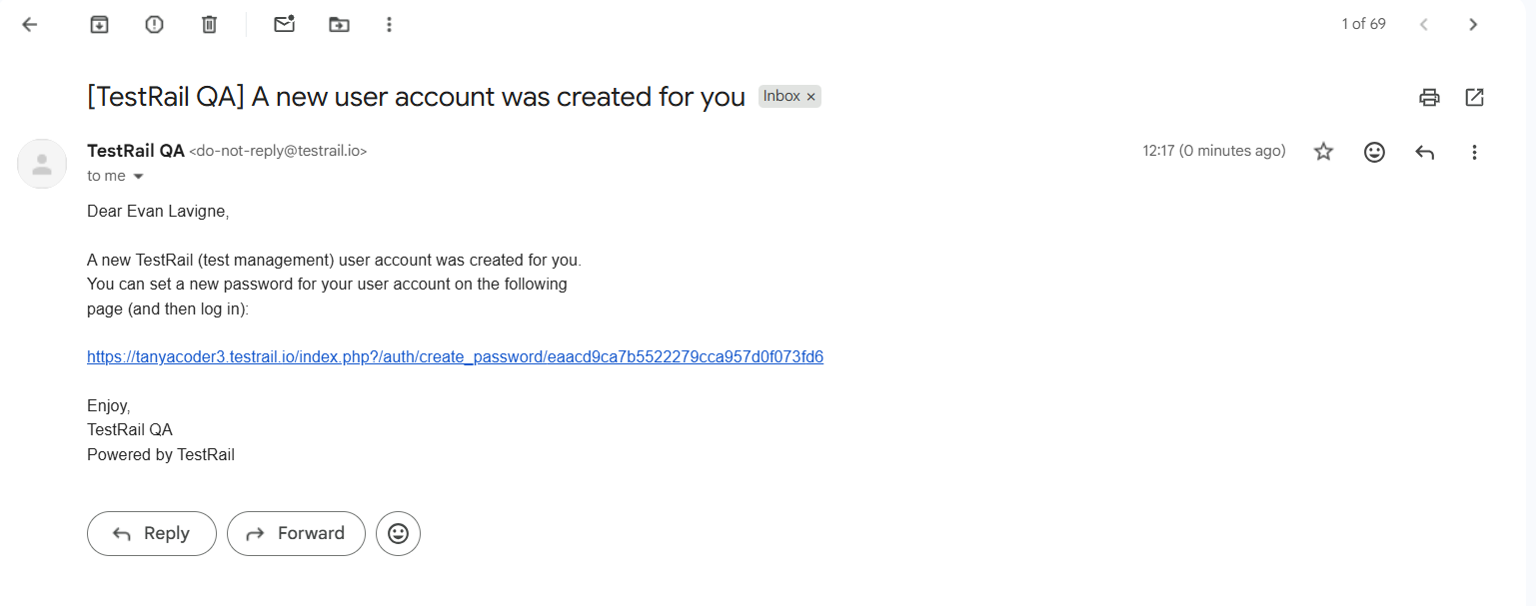

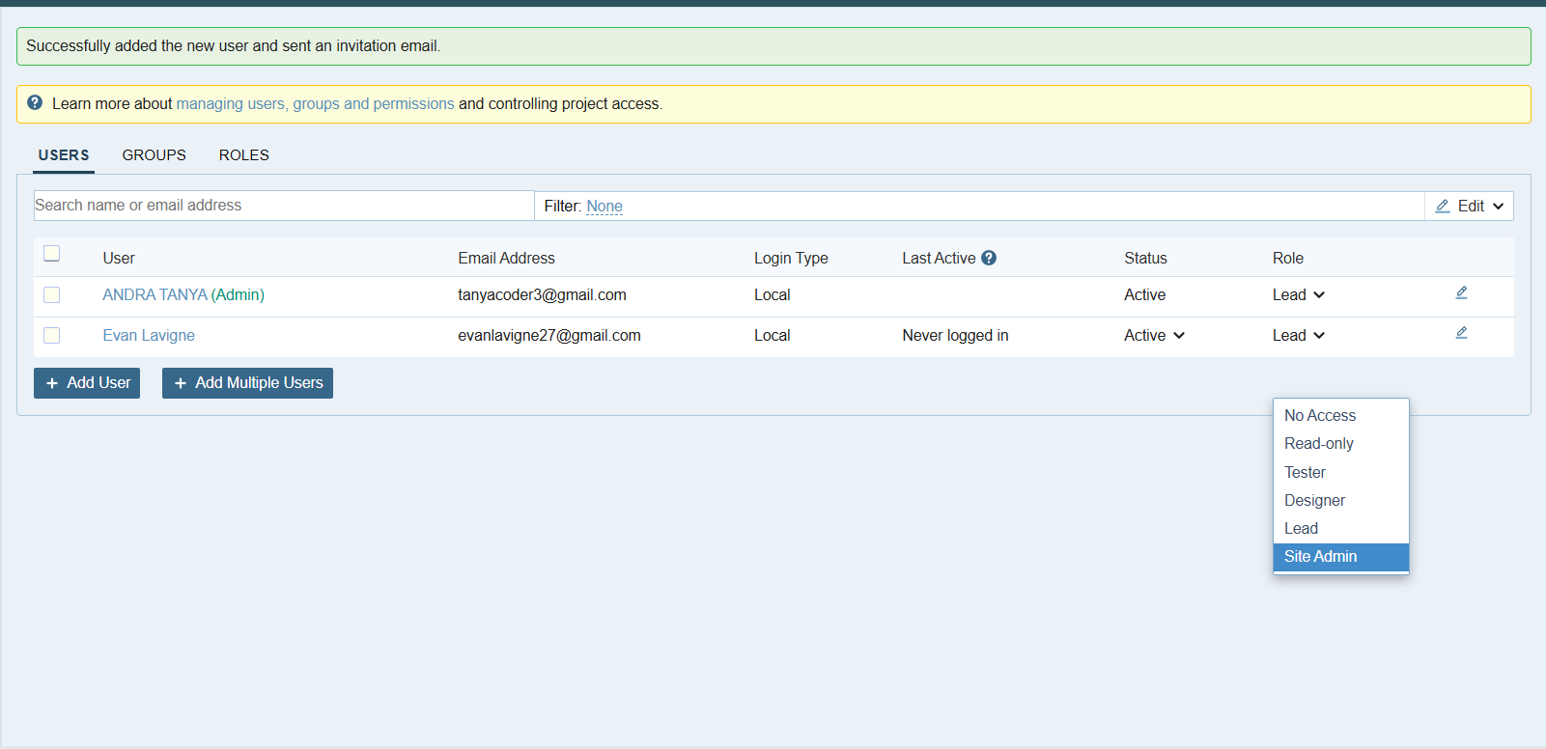

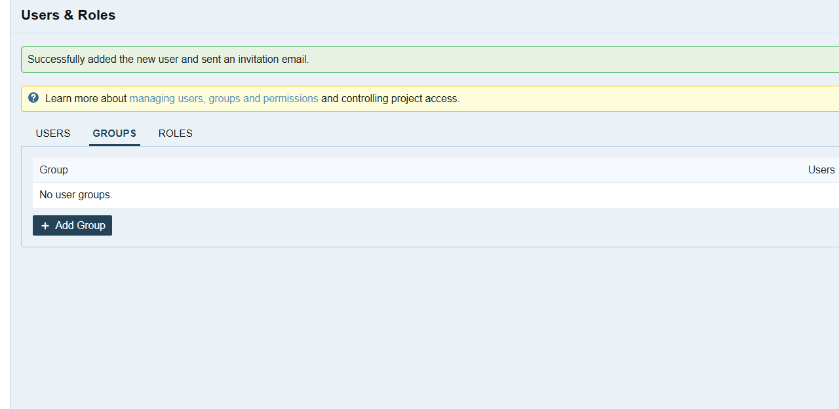

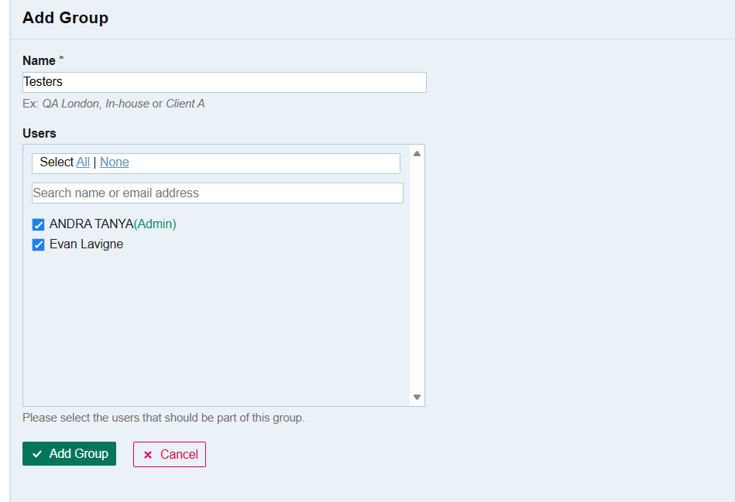

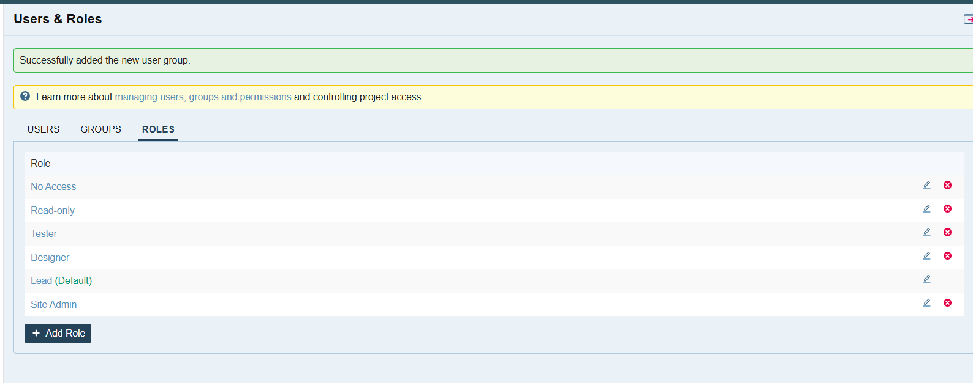

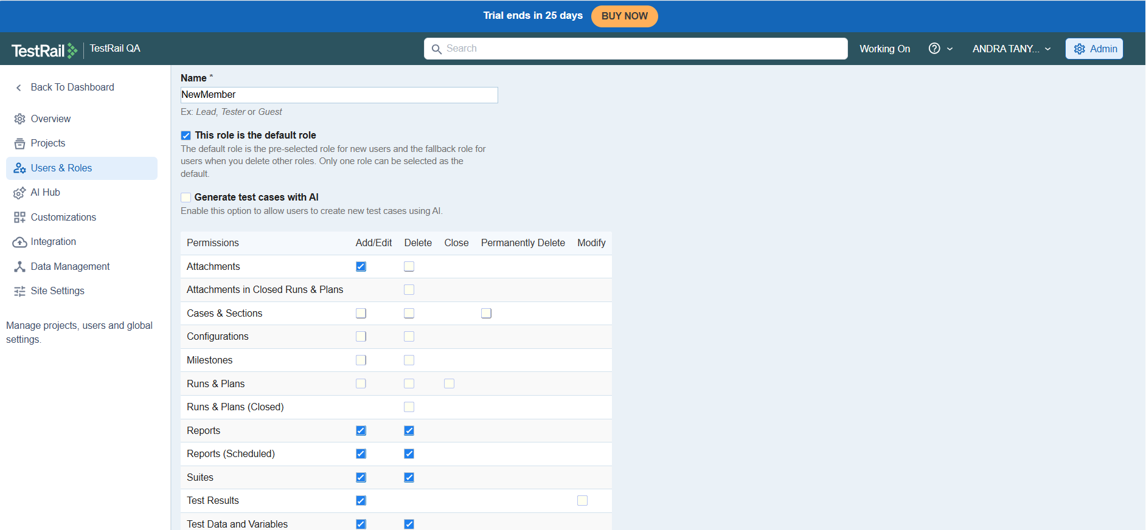

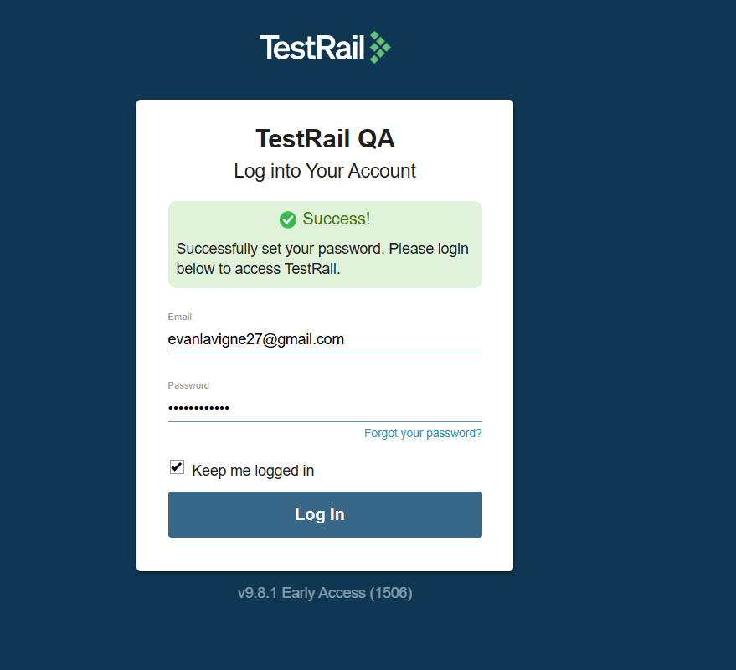

- The Projects section was accessed using a newly created non-administrator user account, demonstrating how projects and test artifacts configured by the administrator are visible to assigned users based on their role and permissions.
- The Projects dashboard displayed all projects assigned to the user, including First Project, Project_Baseline, Project_MultipleTestSuites, Project_SingleRepo, and Sample Project. This confirms that the administrator-configured projects are accessible to the user without requiring admin privileges.
- Each project showed quick-access links to key modules such as To-dos, Milestones, Test Runs, Test Cases, and Reports, indicating that the user has appropriate permissions to view and work with these testing assets.
- Different project structures were visible to the user, including single-repository and multiple test suite configurations, demonstrating that structural decisions made by the administrator are consistently reflected across user accounts.
- Upon opening a project (Project_SingleRepo), the Project Overview page was accessible to the new user, providing a summarized view of milestones, test runs, and recent activity.
- Administrator-created milestones such as Release 1.0 were visible to the user, confirming that release planning and milestone configuration are shared across roles for aligned execution.
- Test runs and test plans created by the administrator were visible to the user, including individual test runs and grouped executions like “Supported Browser + OS testcases,” allowing the user to participate in or review execution activities.
- The Activity section reflected actions performed by the administrator, such as creation of test runs, milestones, and test plans, ensuring transparency and traceability of testing activities across team members.
- The left-side navigation panel allowed the user to access project modules like Test Cases, Test Runs & Results, Milestones, and Reports, based on the permissions assigned to the user’s role.
- Execution status indicators were visible to the user, including passed, failed, blocked, skipped, and automation-related results, enabling the user to understand overall test progress without administrative access.
- These screenshots collectively demonstrate role-based visibility in TestRail, where a non-admin user can view and work with projects and test assets configured by the administrator, ensuring collaboration while maintaining controlled access.

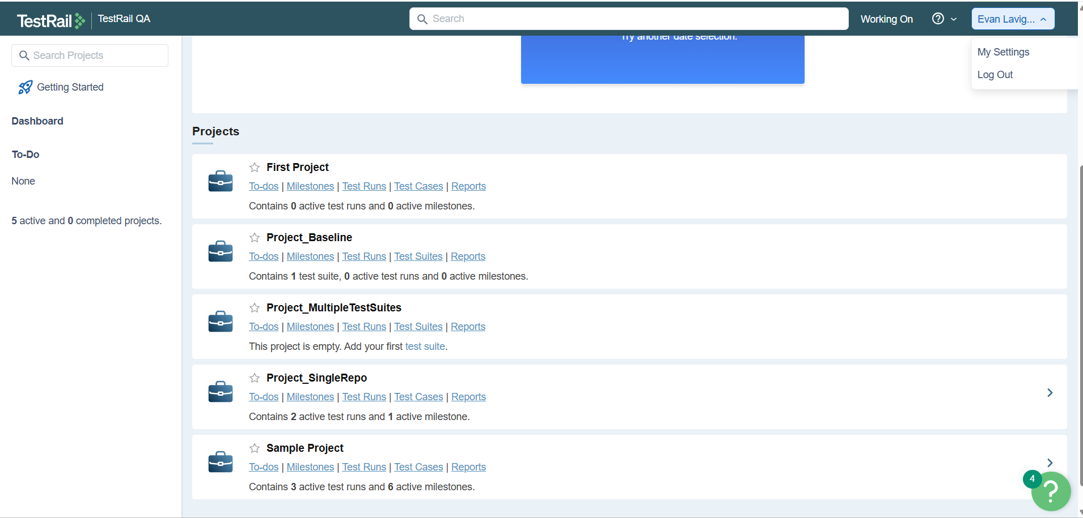

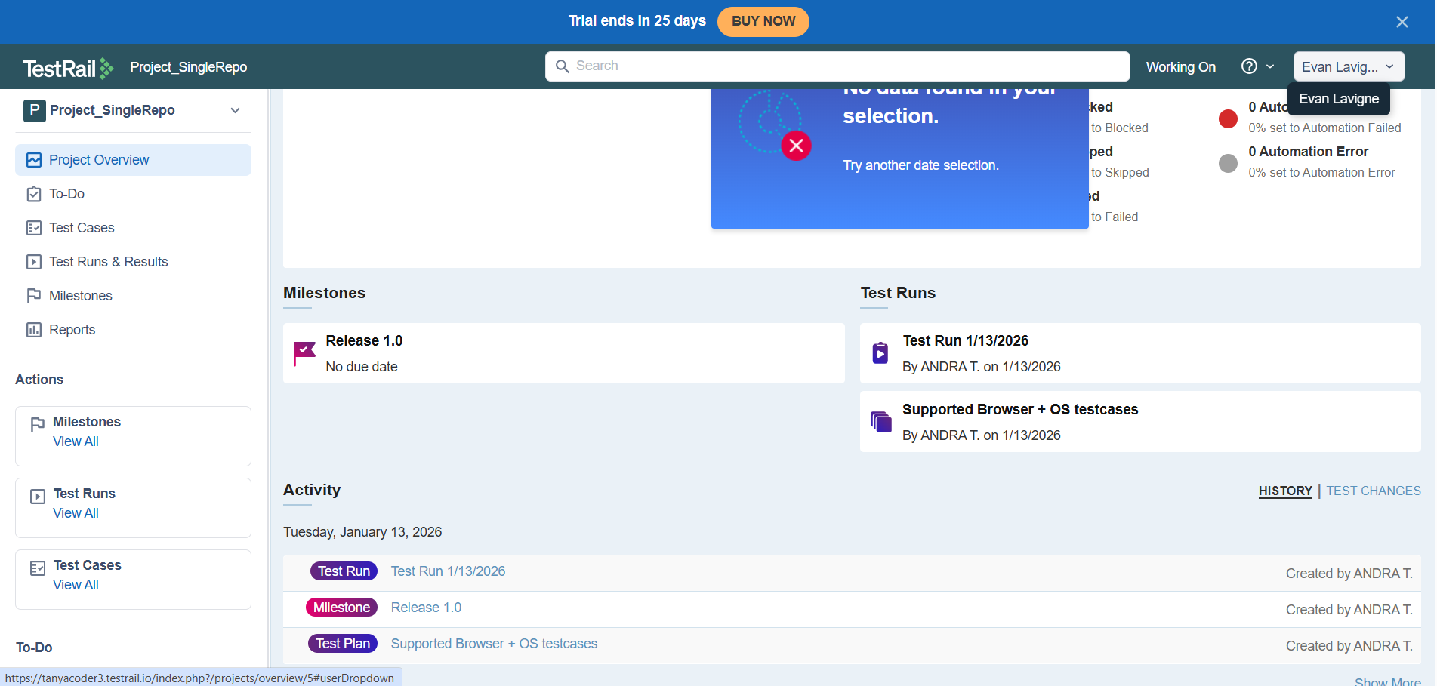

Customizations available in TestRail: (for an administrator in admin board)

- TestRail provides a dedicated Customizations section in the Admin panel, which allows administrators to configure and control how test cases, results, templates, and related entities behave across projects. This helps standardize test management practices while still allowing flexibility where required.
- Case Fields customization was performed to add and manage custom fields used during test case creation. Existing system fields like Estimate, Milestone, References, and Steps are visible, and additional custom fields can be created to capture project-specific information such as automation details or priority.
- A new custom dropdown field named “Priority” was created, where a system name was defined and the field type was set as Dropdown. This ensures structured input and avoids free-text inconsistencies during test case authoring.
- Dropdown options for the Priority field were configured manually, with values like low, medium, and high. A default value was set to “medium,” and the field was marked as required, ensuring that priority selection is mandatory for every test case.
- The custom field was applied to all templates and projects, making it globally available. This ensures consistency across different test case templates and avoids missing priority information in any project.
- After saving, the newly created custom field was successfully reflected in the Case Fields list, confirming that the configuration was applied correctly and is ready for use by testers.
- Result Fields customization was reviewed, which controls what information is captured during test execution. System result fields such as Version, Elapsed time, and Defects are available by default, while custom result fields like Step Results and BDD Scenario Results can be managed as needed.
- Test Case Templates were customized and managed, including existing templates like Behaviour Driven Development, Exploratory Session, Test Case (Steps), and Test Case (Text). Templates help define the structure of test cases based on testing methodology.
- A new test case template was added, with control over whether it should be the default template and which projects it should apply to. The template was limited to selected projects, demonstrating how templates can be scoped instead of being globally applied.
- Case Types were configured to categorize test cases, including types such as Acceptance, Accessibility, Automation, Compatibility, Functional, Regression, Security, Smoke & Sanity, and Usability. These types help classify test cases based on their testing purpose.
- Priorities configuration was verified under the Priorities section, where predefined priority levels like Critical, High, Medium (Default), and Low were available. Each priority includes an abbreviation for clear reporting and filtering.
- Result Statuses customization allows administrators to control execution outcomes used during test runs. System-defined statuses such as Passed, Blocked, Untested, Skipped, and Failed are available by default, each represented with distinct color indicators for quick visual identification in reports and dashboards.
- Custom result statuses were also visible, including Automation Passed, Automation Failed, and Automation Error. These custom statuses help differentiate between manual and automated execution results, improving clarity when analyzing automation coverage and failures.
- Inactive result statuses were displayed but not usable until activated, ensuring that unused or deprecated statuses do not clutter execution workflows. This helps maintain a clean and controlled testing environment.
- Case Statuses customization was reviewed to manage the lifecycle of test cases. System case statuses such as Design (Default), Ready, and Review define the progress stages of a test case from creation to readiness for execution.
- Case statuses help teams track test case maturity, ensuring that only reviewed and approved test cases move forward into execution phases. Administrators can add, edit, or deactivate statuses as per team workflow requirements.
- UI Scripts customization was accessed to manage user interface extensions. An active UI script named “Demo trigger external automation” was visible, demonstrating how TestRail can be extended to trigger external tools or automation workflows directly from the UI.
- UI Scripts allow advanced customization, enabling integration with CI/CD pipelines or automation frameworks by adding custom buttons, actions, or triggers within TestRail’s interface.
- Chart Themes customization was explored to control report visual styling. Multiple predefined chart themes such as Default, Fusion, Gamut, Candy, and Umber were available for selection.
- Changing chart themes improves report readability and presentation, especially when sharing dashboards and metrics with stakeholders. A custom theme option is also available for teams that require specific branding or color contrast.
- Overall, the customization practical demonstrated how an administrator can tailor TestRail to match organizational testing processes by configuring fields, templates, types, priorities, result statuses, case workflows, UI behavior, and reporting visuals, ensuring consistency, traceability, effective execution tracking, and standardized reporting across projects.

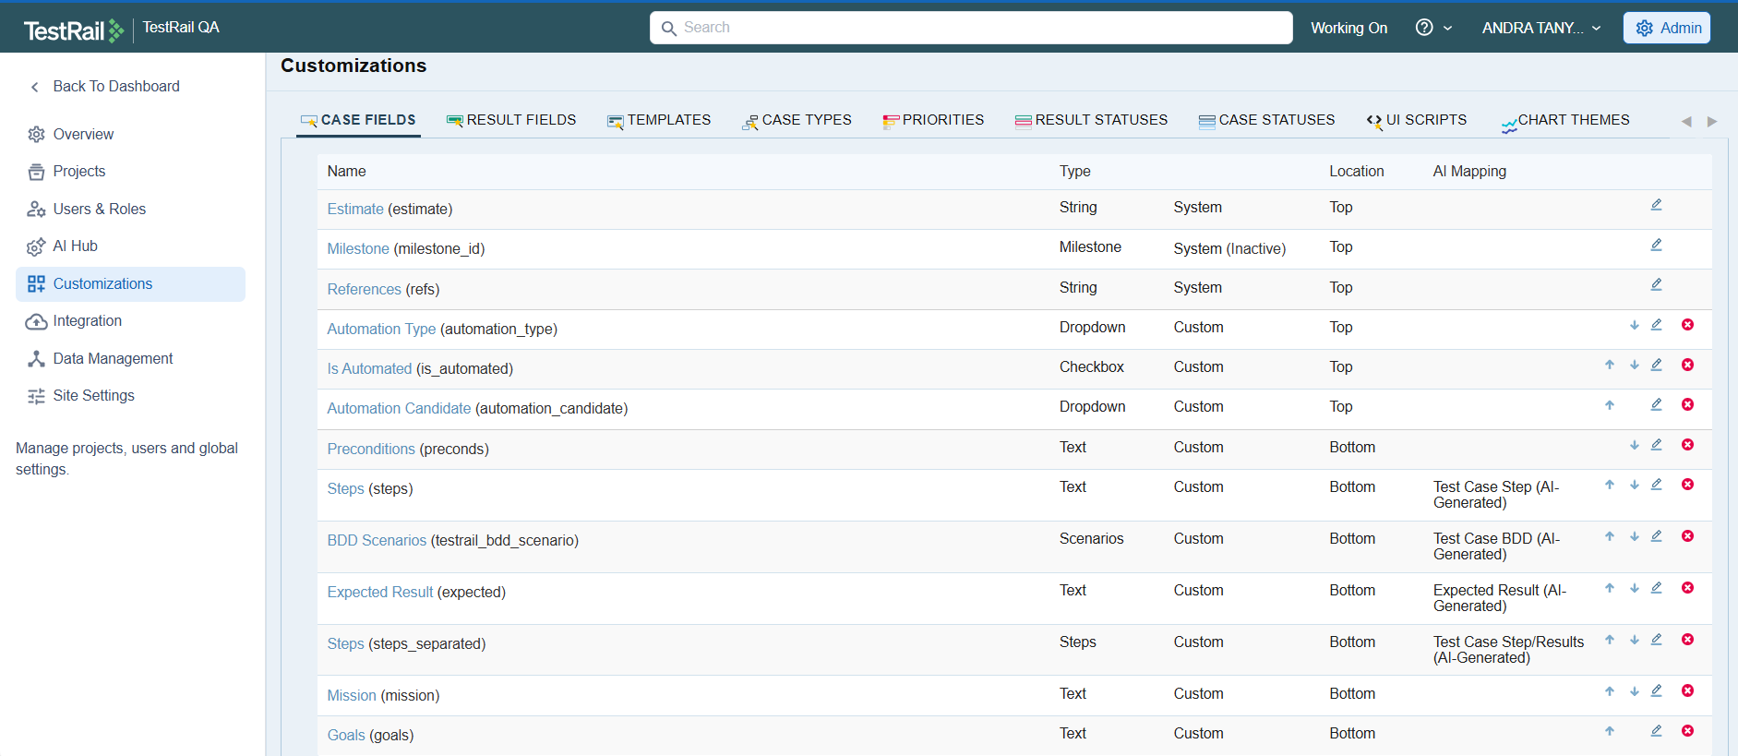

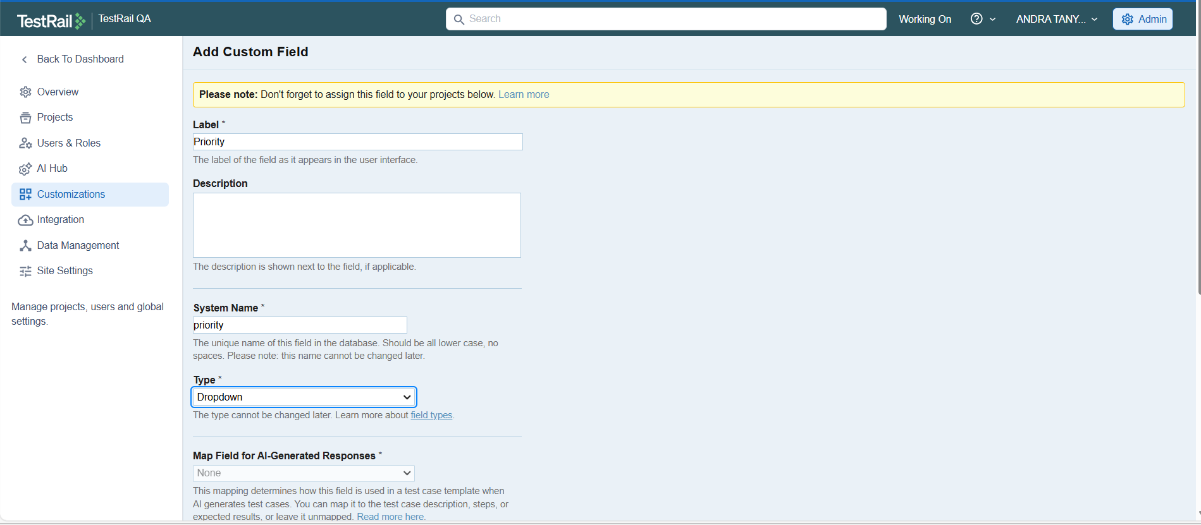

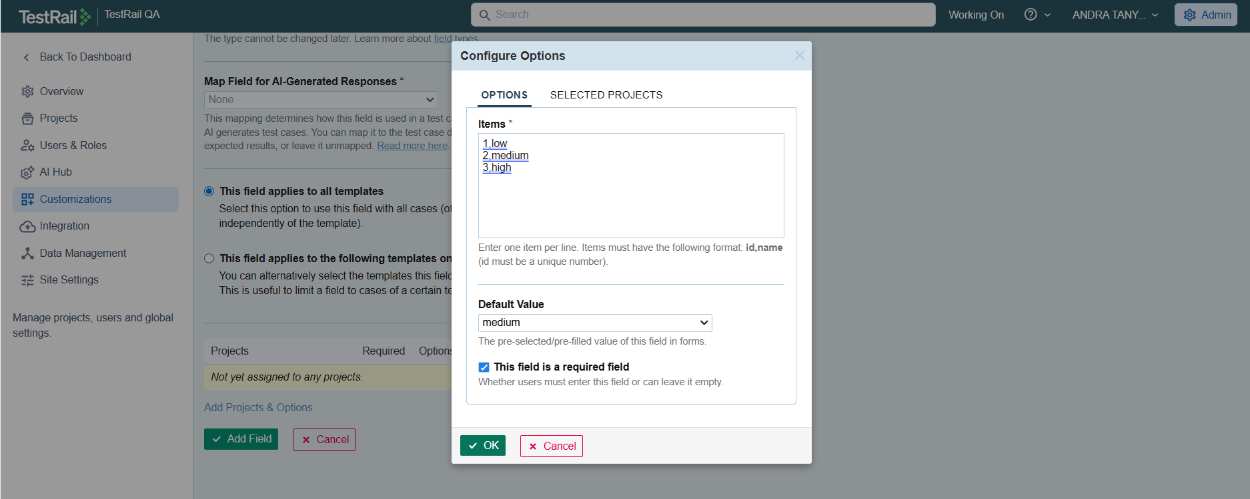

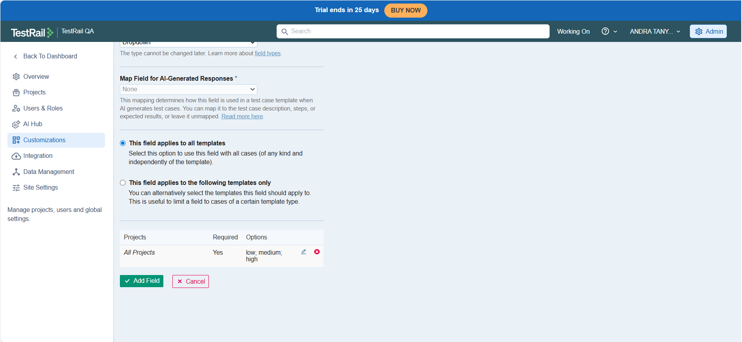

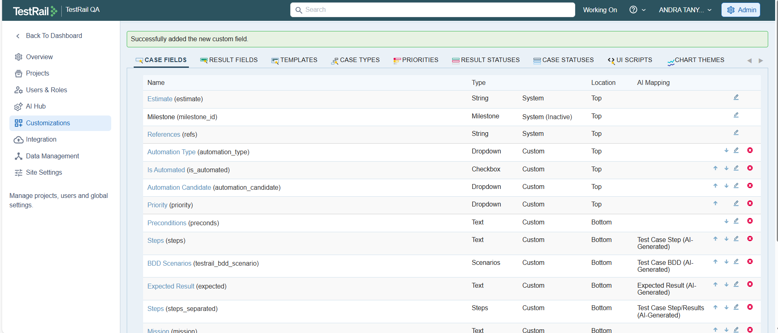

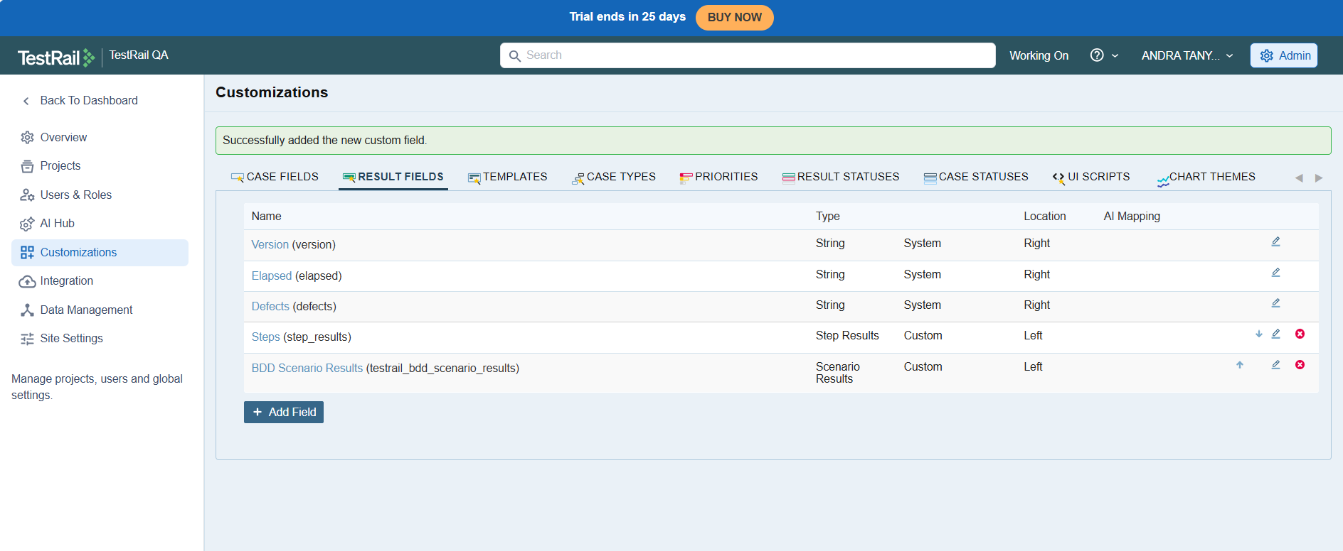

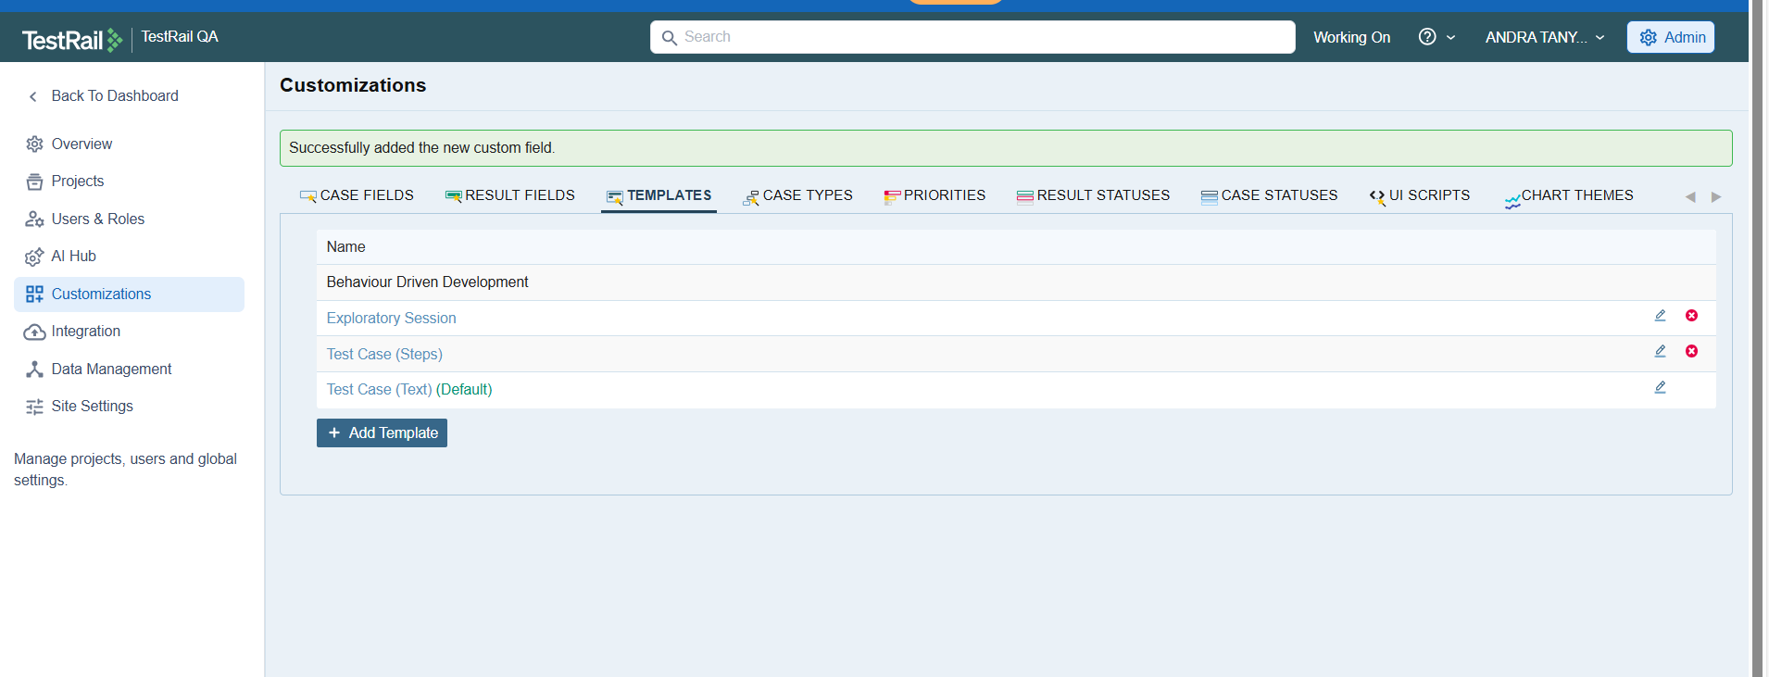

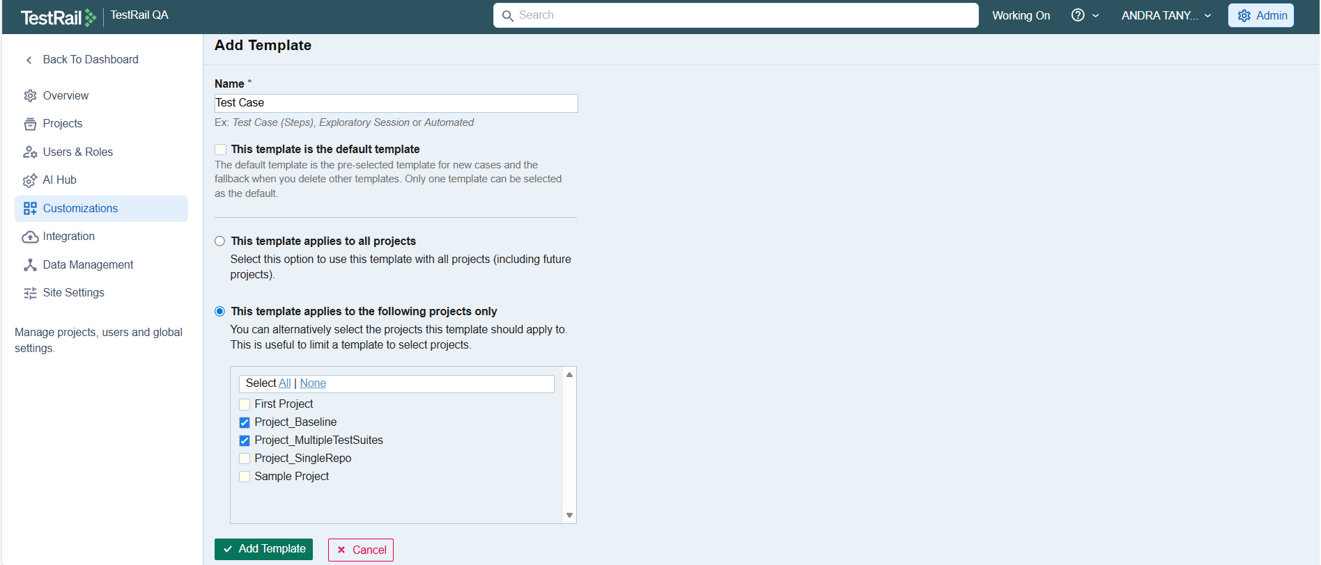

System fields Can’t delete.
Custome fields can delete.

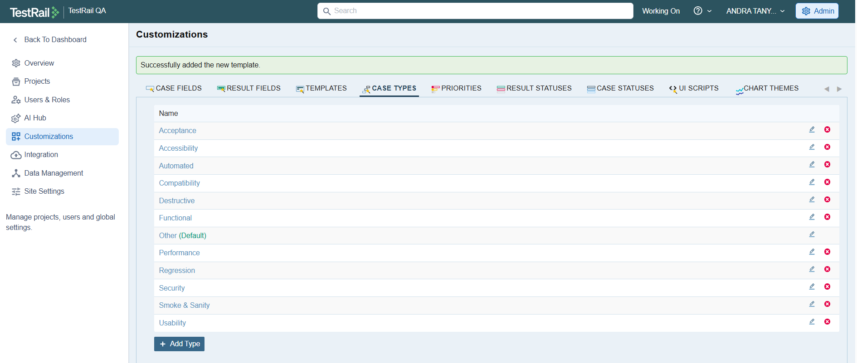

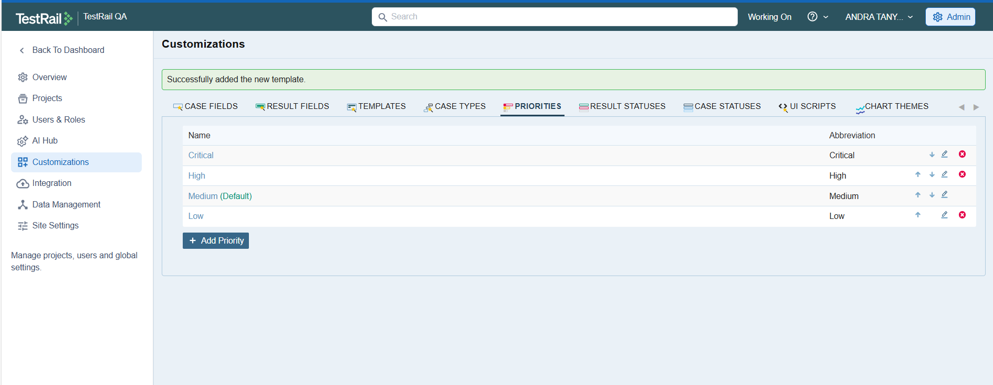

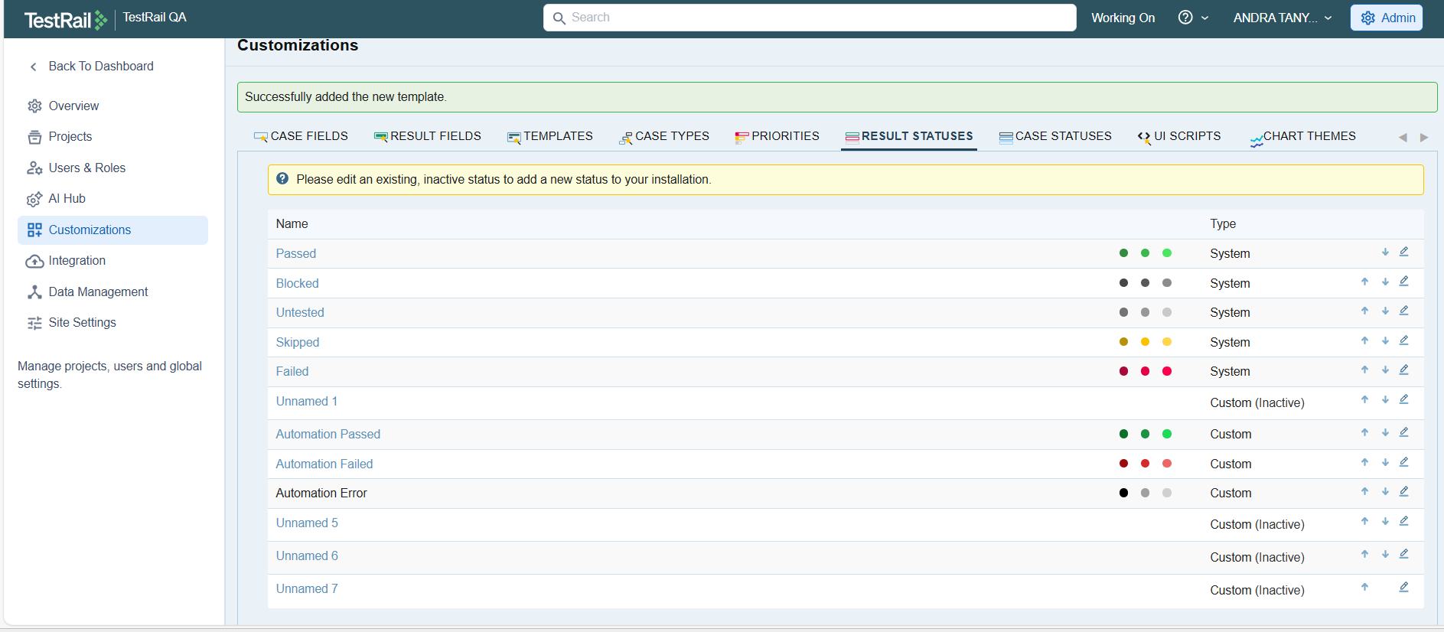

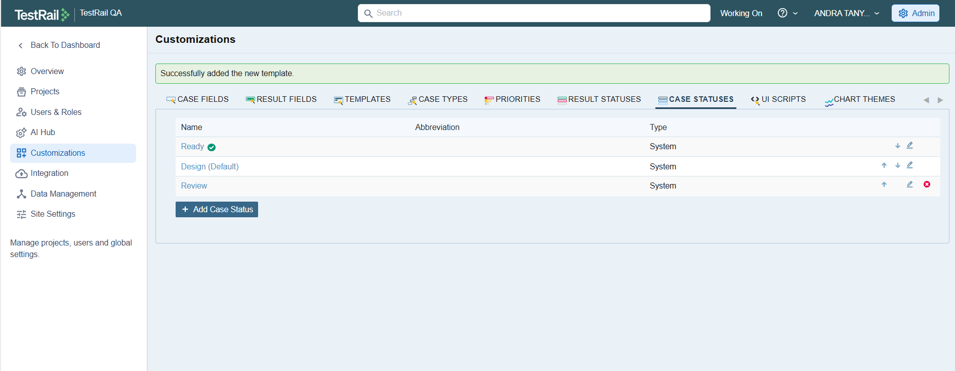
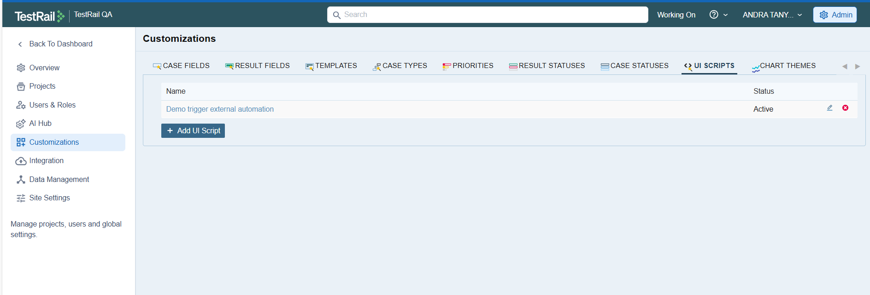

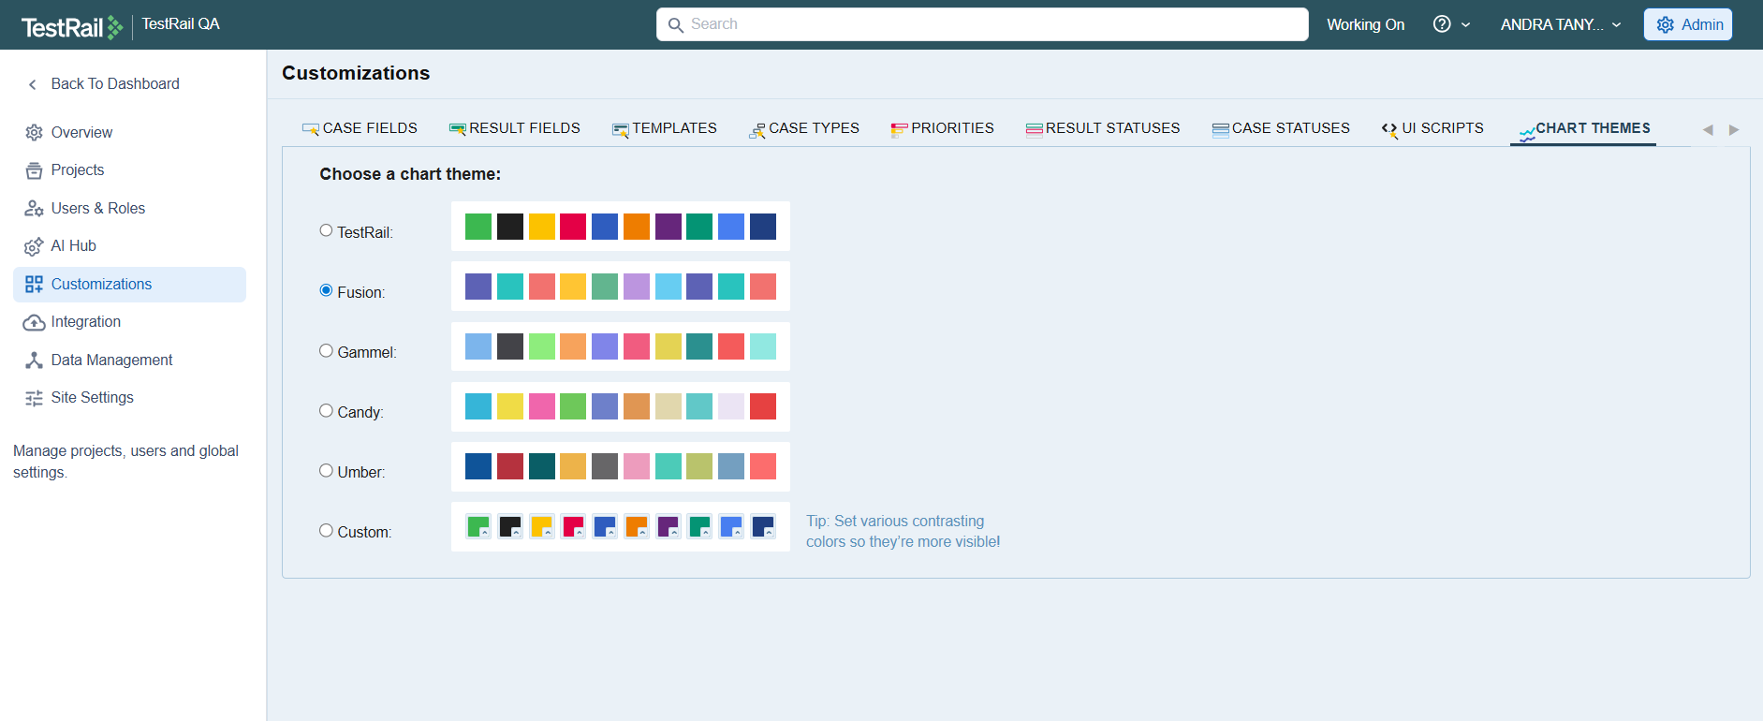

Reporting in TestRail:

The reporting feature in TestRail allows users to generate detailed, real-time insights into test case activity, execution progress, and overall test management health within a project. From the project dashboard, reports can be created using predefined templates that focus on test cases, test runs, and defects.
Administrators can create a report by selecting a report template (such as Activity Summary), defining the report name and description, and configuring report options such as grouping (for example, by day), time range, and the type of changes to include (new or updated test cases). This flexibility enables teams to tailor reports to specific tracking and audit needs.
TestRail also supports access control and scheduling for reports. Reports can be made accessible to all project members or restricted, generated immediately, or scheduled to run automatically at defined intervals (e.g., daily). Once generated, reports can be shared within TestRail or distributed via email as links or attachments, supporting efficient communication with stakeholders.
The generated reports provide both visual and tabular representations of data, including charts showing test case creation and updates over time, as well as detailed change logs listing individual test cases and their modification history. This ensures transparency, traceability, and data-driven decision-making throughout the testing lifecycle.
Overall, TestRail’s reporting functionality enables effective monitoring of testing activities, supports regular status updates, and helps ensure that testing progress and quality metrics are consistently tracked and communicated across the project.

